Project Report

Waste Management App
Course Code : CSE226
Course Title: Developing Android Apps

Submitted By:
Name:- Nagakalyan Ravuri
Reg No:- 12220944
Name:- Mandadapu Chandravadhan
Reg No:- 12222491
Name:- A. Akash Goud
Reg No:- 12221995

Submitted To:
DR. Vikas Sharma


LOVELY PROFESSIONAL UNIVERSITY

DECLARATION
I Mandadapu Chandravadhan a student of Bachelor of Technology under CSE discipline at Lovely Professional University, Punjab, hereby declare that all the information furnished in this project report is based on my own work and is genuine

Your name: Mandadapu Chandravadhan
Registrartion Number: 12222491

Table of Contents

- Project Description
Waste Management is an Android app that blends computer vision and conversational AI to promote responsible disposal habits. Users can capture or pick a waste image, run the TensorFlow Lite classifier on-device, and immediately see the waste category plus confidence. The app then combines the classification with curated disposal instructions and stores both, so each scan contributes to a searchable waste history. A built-in AI chatbot—currently rule-based with Gemini-ready hooks—delivers recycling tips, eco facts, and guidance on tricky materials. The entire experience follows MVVM best practices, uses coroutines for smooth background work, and supports multiple languages via dedicated resource files.

- Technology Used (Front End/Back End)
Android Studio, TensorFlow lite, Coroutines, API’s.

- Screenshots of the project

1.Main Activity Code:-
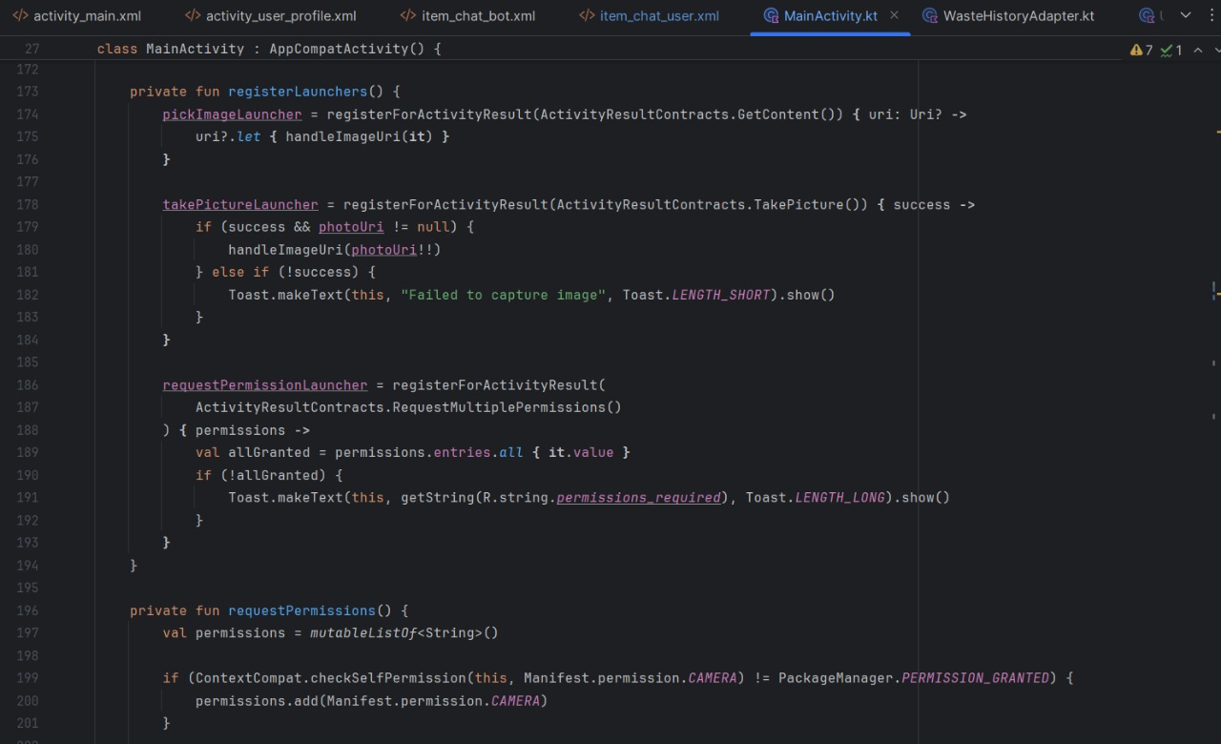

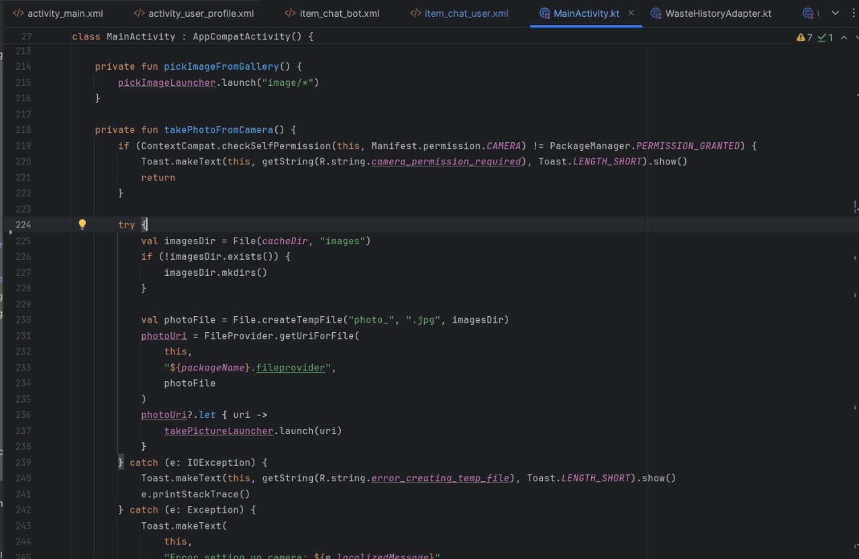
2.Tensor Flow Code:-
3.Activity Main XML Code:-
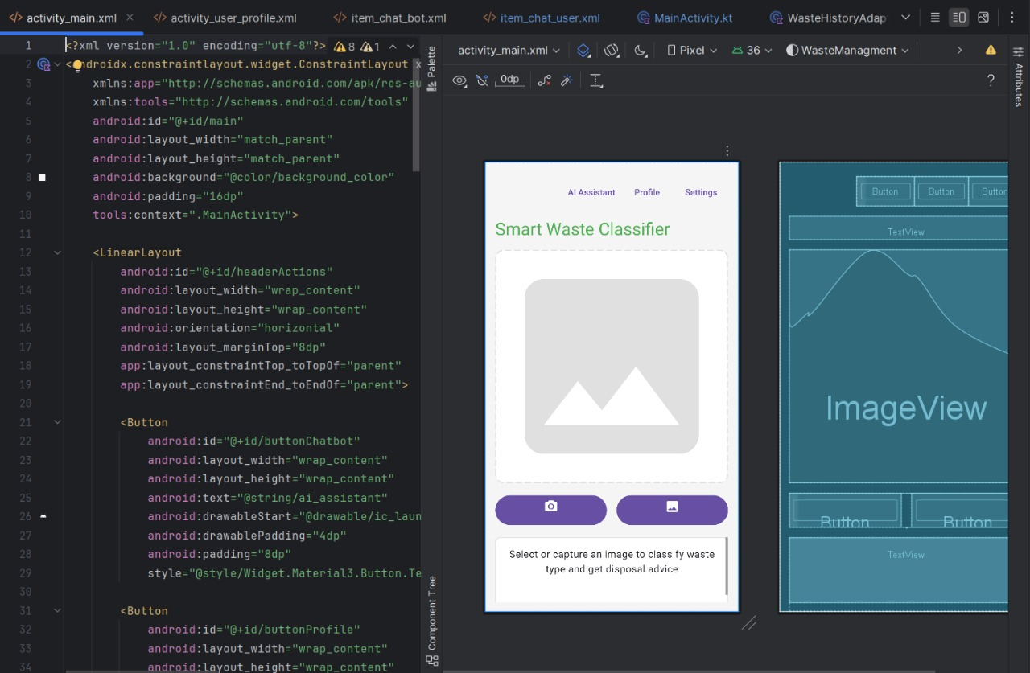

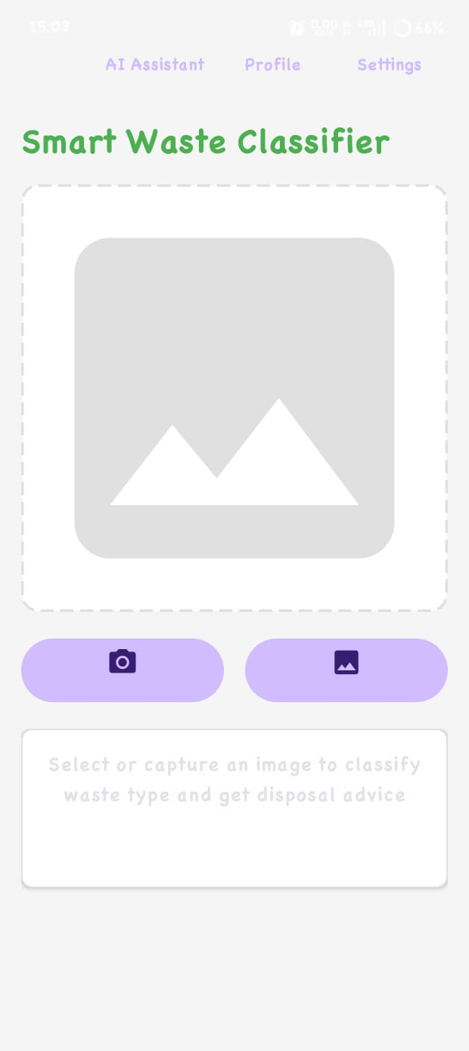


Conclusion
The project already delivers a cohesive experience: capture/choose waste images, classify them reliably on-device, surface contextual advice, keep a running history, and chat with an assistant for broader sustainability questions. The codebase is cleanly structured (MVVM), dependency-ready for cloud AI, and localized, making it easy to maintain or extend. Even with the mock fallback, the classifier handles common waste categories, ensuring the app stays functional without network or model file issues.
Future Scope
- Real LLM integration: swap the rule-based chatbot with OpenAI/Gemini/Claude calls, including streaming replies and better context handling.
- Realtime camera classification: continuous preview inference for faster feedback, plus batching multiple photos.
- Model improvements: auto-download updated TFLite models, apply quantization, add edge detection or preprocessing filters.
- Analytics & gamification: show personal impact stats, leaderboards, streaks, or community challenges.
- Voice + accessibility: voice commands, TTS responses, and better screen-reader support.
- Cloud sync & sharing: sync history across devices, export PDFs, or share classification details with municipalities.

- GitHub URL Link
https://github.com/chandra8705/Waste-Management-

